EXP-3A-GENERATION OF PHASE MODULATED (PM) SIGNALS AND CALCULATION OF PHASE DEVIATION USING MATLAB SIMULATION
Objectives:
i) To generate a Phase Modulated (PM) signal in MATLAB using specified carrier and message
signal parameters.
ii) To observe and analyze the time-domain characteristics of the message signal, carrier signal,
and phase modulated signal through MATLAB simulation.
iii) To calculate the phase deviation of the PM signal using the phase sensitivity constant and
message signal amplitude.
iv) To determine the modulation index of the PM signal and examine its relationship with phase
deviation.
v) To investigate the effect of varying message signal amplitude on the phase deviation and
modulation characteristics of the PM signal.
vi) To compare PM waveforms obtained for different phase deviation values and analyze their
modulation behavior using MATLAB.
PROGRAM (MATLAB CODE)
clc;
clear;
close all;
% Parameters
Am = 1; % Message Amplitude (V)
fm = 100; % Message Frequency (Hz)
Ac = 5; % Carrier Amplitude (V)
fc = 1000; % Carrier Frequency (Hz)
fs = 20*fc; % Sampling Frequency (Hz)
kp = pi/2; % Phase Sensitivity (rad/V)
% Time Vector

t = 0:1/fs:4/fm;
% Message Signal
m = Am*sin(2*pi*fm*t);
% Carrier Signal
c = Ac*cos(2*pi*fc*t);
% Phase Modulated Signal
pm = Ac*cos(2*pi*fc*t + kp*m);
% Phase Deviation
phase_dev = kp*Am;
% PM Modulation Index
mp = phase_dev;
% Display Results
fprintf('Message Amplitude = %.2f V\n',Am);
fprintf('Message Frequency = %.0f Hz\n',fm);
fprintf('Carrier Amplitude = %.2f V\n',Ac);
fprintf('Carrier Frequency = %.0f Hz\n',fc);
fprintf('Phase Sensitivity = %.2f rad/V\n',kp);
fprintf('Phase Deviation = %.2f radians\n',phase_dev);
fprintf('PM Modulation Index = %.2f\n',mp);
% Plotting
figure('Name','Phase Modulation and Phase Deviation',...
'NumberTitle','off');
subplot(2,2,1);
plot(t,m,'LineWidth',1.5);
title('Message Signal');
xlabel('Time (s)');
ylabel('Amplitude');
grid on;
subplot(2,2,2);
plot(t,c,'LineWidth',1.5);
title('Carrier Signal');
xlabel('Time (s)');
ylabel('Amplitude');
grid on;
subplot(2,2,3);
plot(t,pm,'LineWidth',1.5);
title('Phase Modulated Signal');
xlabel('Time (s)');
ylabel('Amplitude');
grid on;
subplot(2,2,4);
bar(phase_dev);
title('Phase Deviation');
ylabel('Radians');
set(gca,'XTickLabel',{'PM Signal'});
grid on;
RESULT:

Message Amplitude = 2.00 V
Message Frequency = 200 Hz
Carrier Amplitude = 15.00 V
Carrier Frequency = 2000 Hz
Phase Sensitivity = 1.57 rad/V
Phase Deviation = 3.14 radians
PM Modulation Index = 3.14
>>

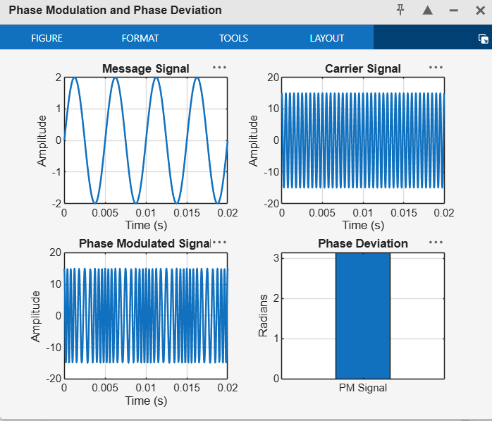
RESULT
The Phase Modulated (PM) signal was successfully generated and analyzed using MATLAB. The phase deviation was calculated from the phase sensitivity constant and message amplitude.
EXP 3 (B)-POWER SPECTRAL DENSITY (PSD) ANALYSIS OF PHASE MODULATED (PM) SIGNALS USING MATLAB

Objectives :
i)To generate a Phase Modulated (PM) signal in MATLAB using specified carrier and message signal parameters.
ii) To compute the frequency spectrum of the PM signal using the Fast Fourier Transform (FFT).
iii) To calculate and plot the Power Spectral Density (PSD) of the PM signal using MATLAB. iv) To identify the carrier component and sideband frequencies present in the PM spectrum. v) To analyze the effect of phase modulation on the spectral distribution and bandwidth of the transmitted signal. vi)To investigate the influence of modulation index on the Power Spectral Density characteristics of the PM signal.
clc;
clear;
close all;
%% Power Spectral Density (PSD) Analysis of Phase Modulated Signal
% Parameters
Am = 5; % Message Amplitude (V)
fm = 400; % Message Frequency (Hz)
Ac = 15; % Carrier Amplitude (V)
fc = 5000; % Carrier Frequency (Hz)
fs = 30*fc; % Sampling Frequency (Hz)
kp = pi/2; % Phase Sensitivity (rad/V)
%% Time Vector
t = 0:3/fs:4/fm;
%% Message Signal
m = Am*sin(2*pi*fm*t);
%% Carrier Signal
c = Ac*cos(2*pi*fc*t);
%% Phase Modulated Signal
pm = Ac*cos(2*pi*fc*t + kp*m);
%% Phase Deviation
beta = kp*Am;
%% FFT Calculation
N = length(pm);
PM_FFT = abs(fftshift(fft(pm)))/N;
% Frequency Axis
f = linspace(-fs/2,fs/2,N);
%% Power Spectral Density Calculation
PSD = (abs(fftshift(fft(pm))).^2)/(N*fs);
%% Bandwidth Calculation using Carson's Rule
BW = 2*(beta+1)*fm;
%% Display Results
fprintf('------------------------------------\n');
fprintf('Phase Modulation Analysis\n');
fprintf('------------------------------------\n');
fprintf('Message Frequency = %.2f Hz\n',fm);
fprintf('Carrier Frequency = %.2f Hz\n',fc);
fprintf('Phase Sensitivity = %.2f rad/V\n',kp);
fprintf('Phase Deviation = %.2f radians\n',beta);
fprintf('Estimated Bandwidth = %.2f Hz\n',BW);
fprintf('------------------------------------\n');
%% Plot Results
figure('Name','PSD Analysis of PM Signal','NumberTitle','off');
% Message Signal
subplot(2,2,1);
plot(t,m,'LineWidth',1.5);
title('Message Signal');
xlabel('Time (s)');
ylabel('Amplitude (V)');
grid on;
% Phase Modulated Signal
subplot(2,2,4);
plot(t,pm,'LineWidth',1.5);
title('Phase Modulated Signal');
xlabel('Time (s)');
ylabel('Amplitude (V)');
grid on;
% Frequency Spectrum
subplot(2,3,3);
plot(f,PM_FFT,'LineWidth',1.5);
title('Frequency Spectrum of PM Signal');
xlabel('Frequency (Hz)');
ylabel('Magnitude');
grid on;
% Power Spectral Density
subplot(2,4,4);
plot(f,PSD,'LineWidth',1.5);
title('Power Spectral Density of PM Signal');
xlabel('Frequency (Hz)');
ylabel('Power/Frequency');
grid on;
%% Separate PSD Plot
figure('Name','PSD Plot','NumberTitle','off');
plot(f,10*log10(PSD),'LineWidth',1.5);
title('Power Spectral Density in dB');
xlabel('Frequency (Hz)');
ylabel('PSD (dB/Hz)');
grid on;
%% Zoomed Spectrum Around Carrier Frequency
figure('Name','PM Spectrum Around Carrier','NumberTitle','off');
plot(f,PM_FFT,'LineWidth',1.5);
xlim([500 1500]);
title('PM Spectrum Around Carrier Frequency');
xlabel('Frequency (Hz)');
ylabel('Magnitude');
grid on;
RESULT:
------------------------------------
Phase Modulation Analysis
------------------------------------
Message Frequency = 400.00 Hz
Carrier Frequency = 5000.00 Hz
Phase Sensitivity = 1.57 rad/V
Phase Deviation = 7.85 radians
Estimated Bandwidth = 7083.19 Hz
------------------------------------
>>

